Tiller Installation

Install the friction plate inside the mounting puck on the tiller mounting frame.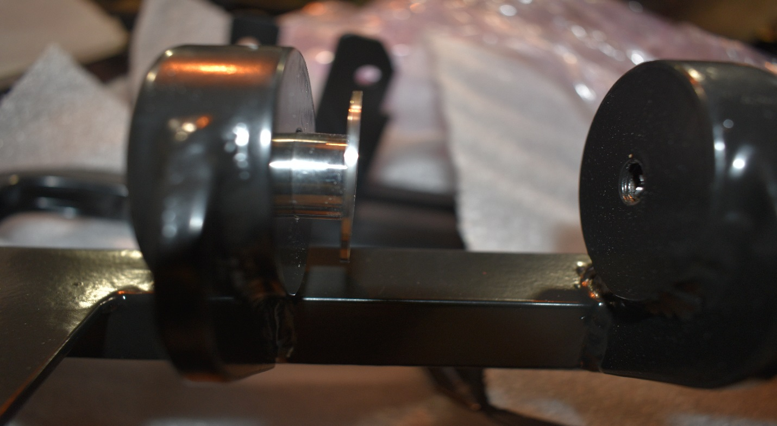
Install tiller assembly and insert M10 bolt with washers from the starboard side puck and thread into the port side puck.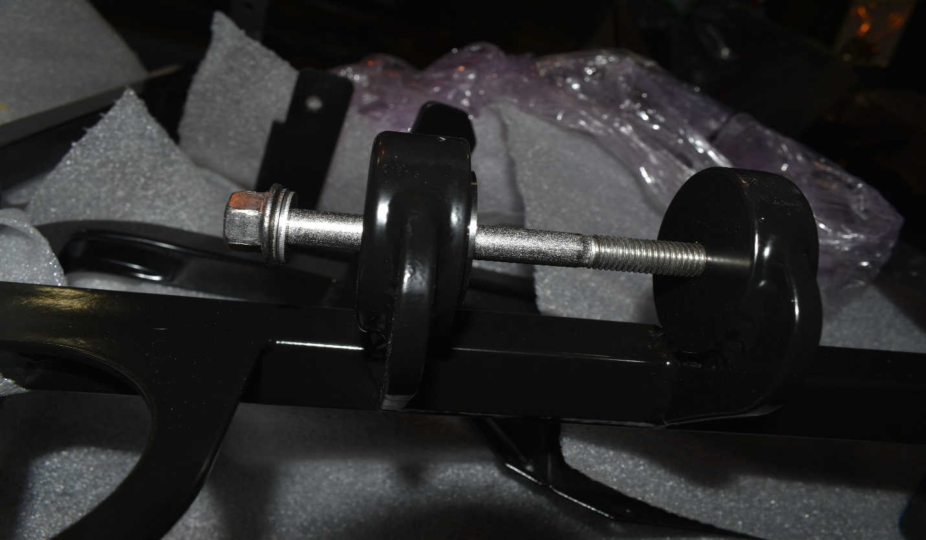
Tighten the bolt using a 15mm socket to engage the friction plate to desired resistance. Once that step is complete you will secure the bolt utilizing the supplied nylon lock nut.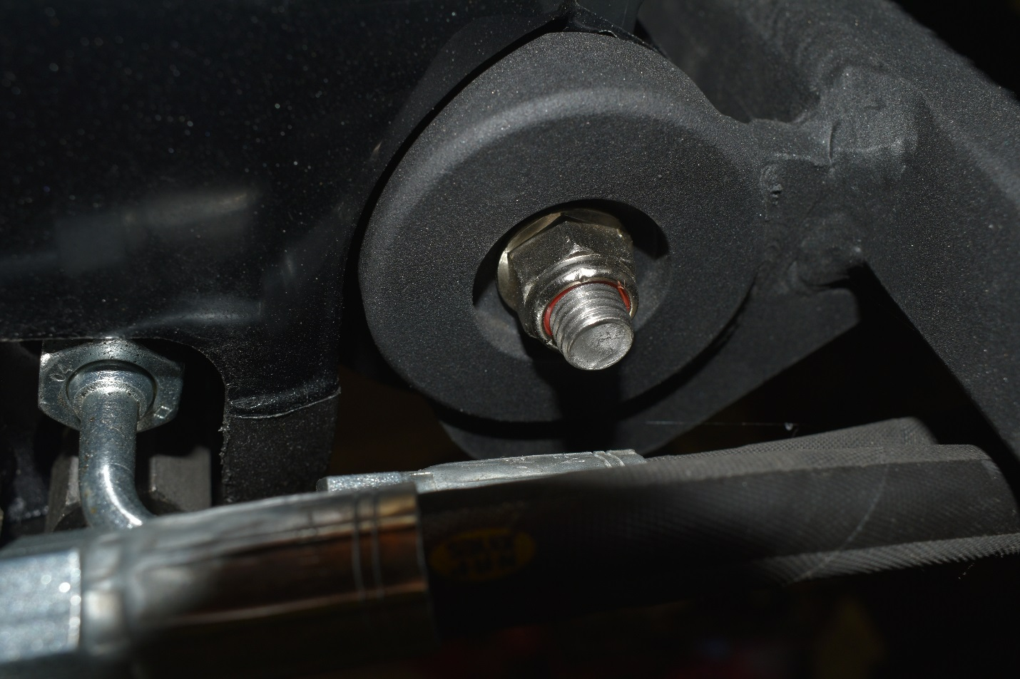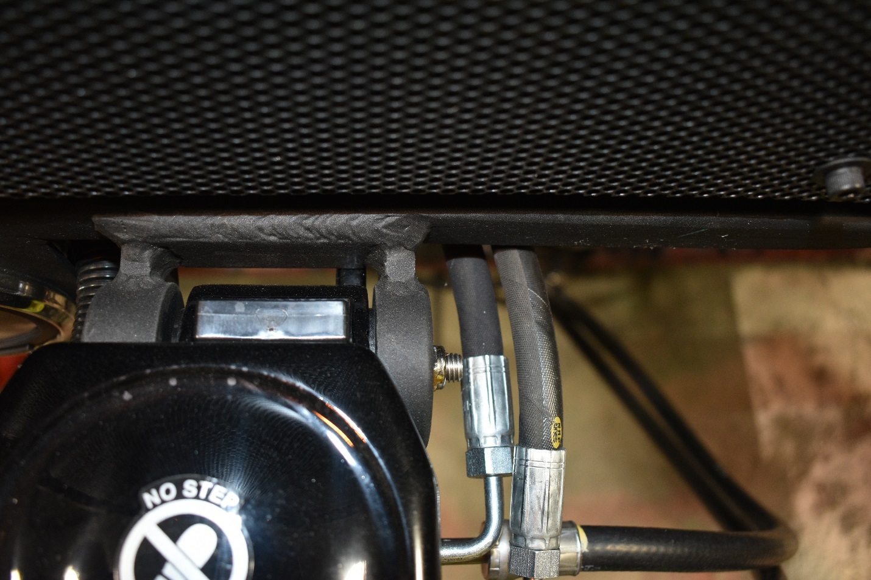

Route the wiring harness behind the tach and secure to where the harness will not contact any moving parts.
Locate the 21 pin connector on the tiller harness and connect to the engine harness, the tach harness will be in the same location and can be installed at the same time. 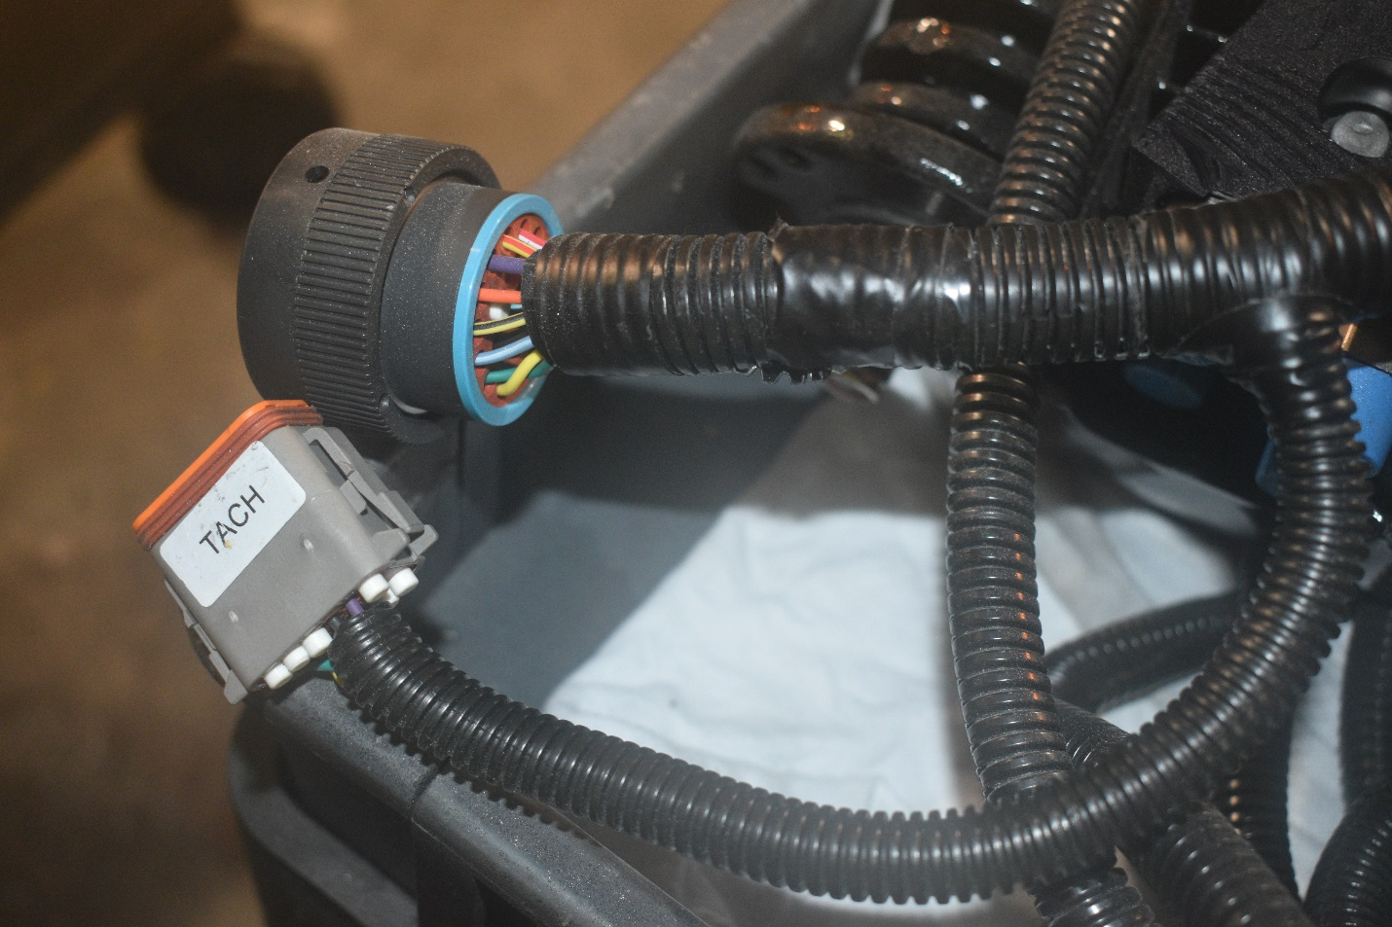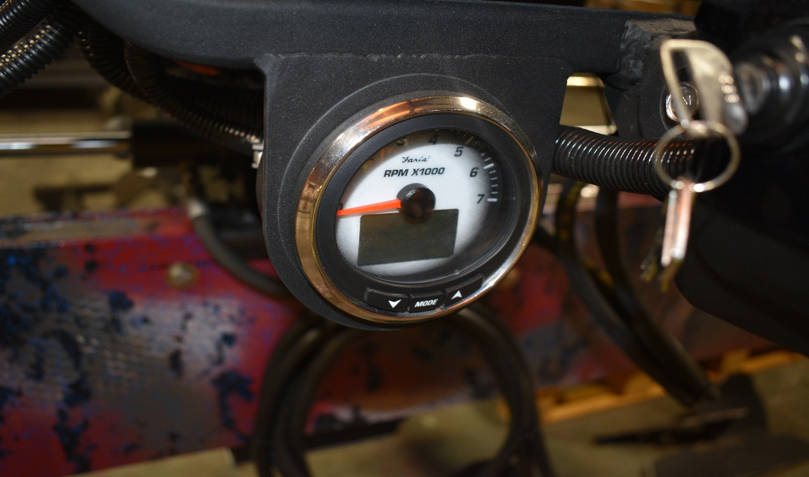
Plug the tach harness into the backside of the faria tach as shown.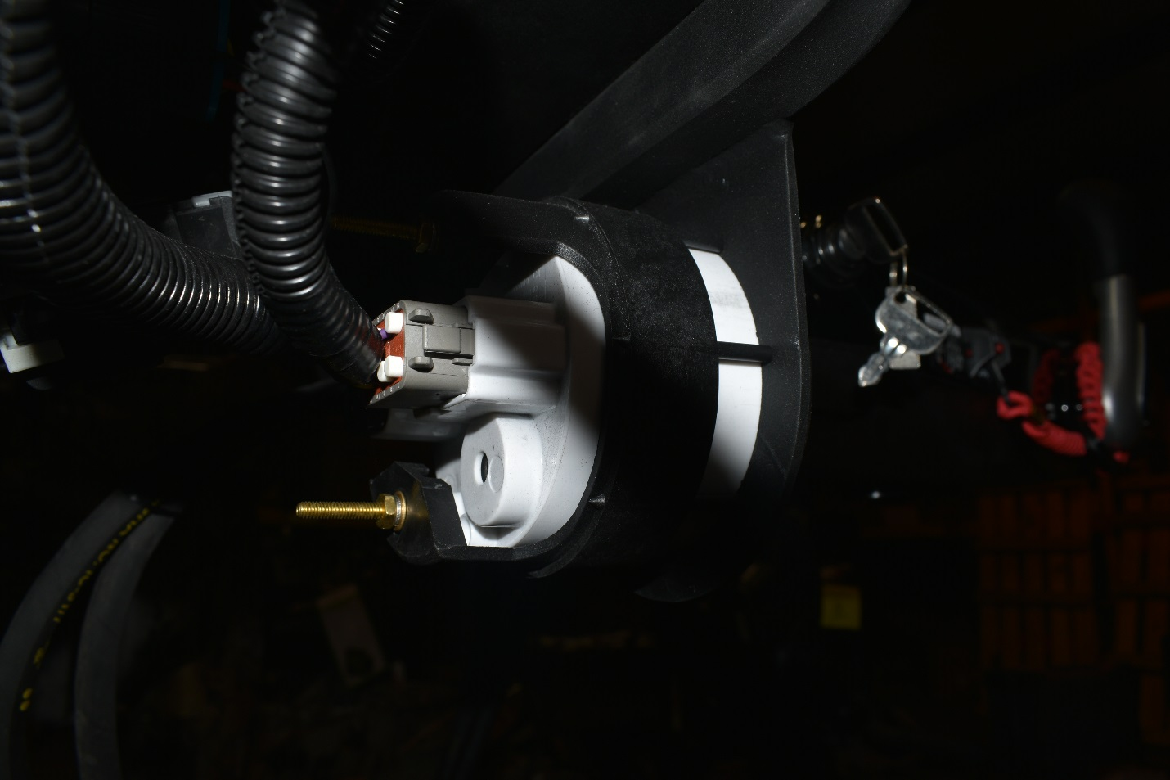

Route the shift cable using the Gen II end (end with out the adjustment barrel) through the underside of the air intake manifold.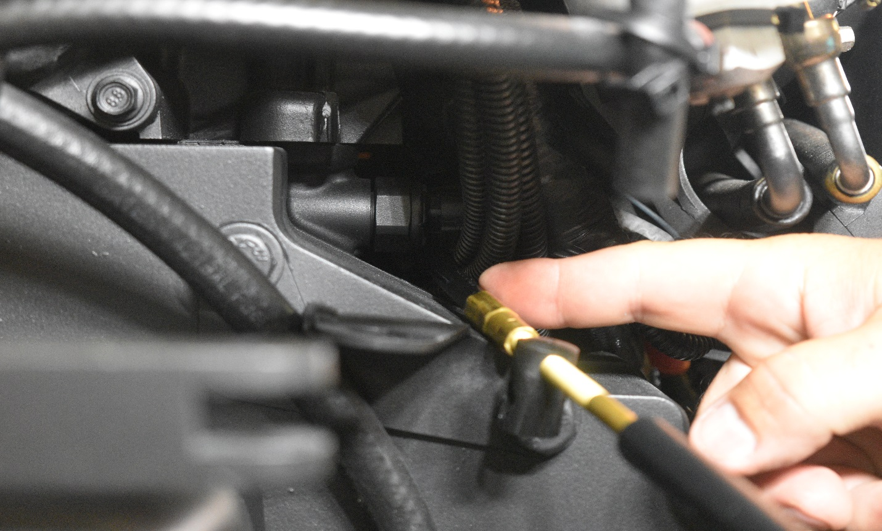
The cable should come out and route by the alternator as shown, then route cable through the rigging tube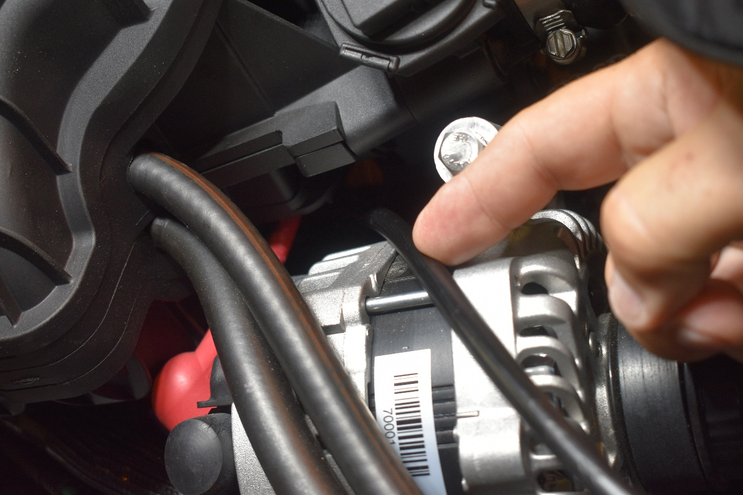

Route the cable out of the rigging tube and make a loop in the cable to run behind the tach and into the tiller handle.
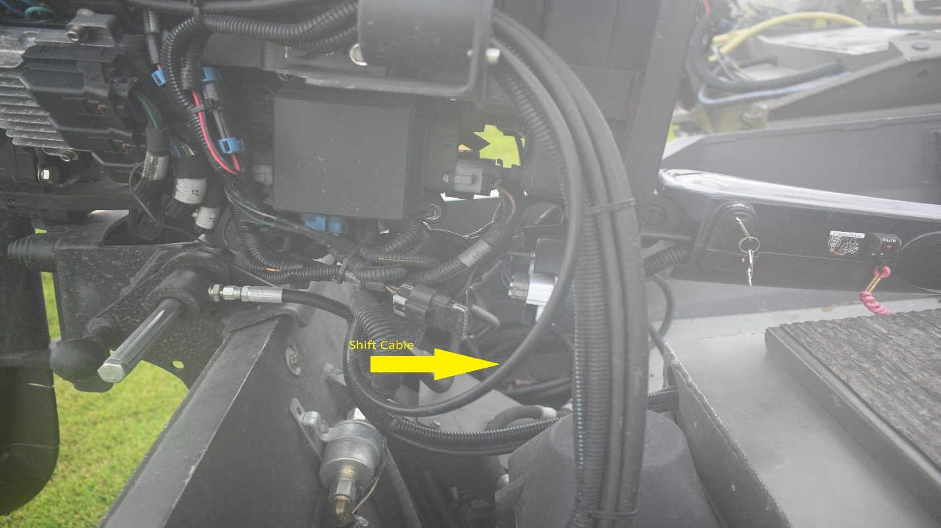
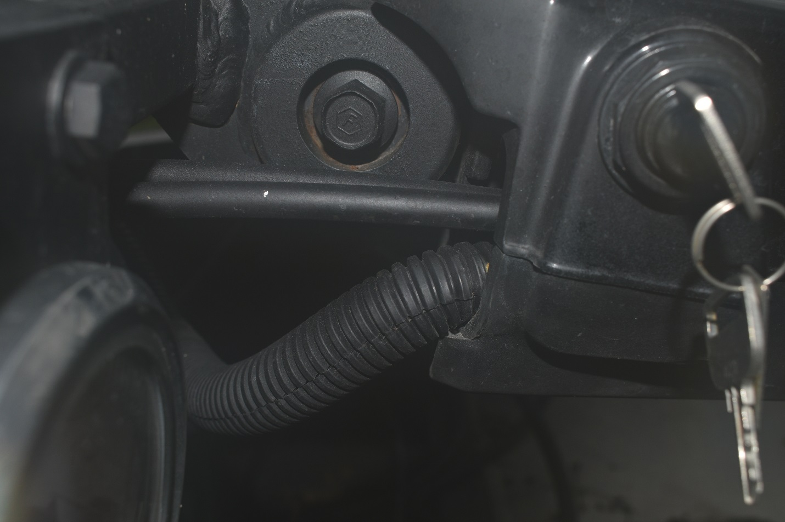
Secure the shift cable and throttle cables with the supplied clasp and bolts.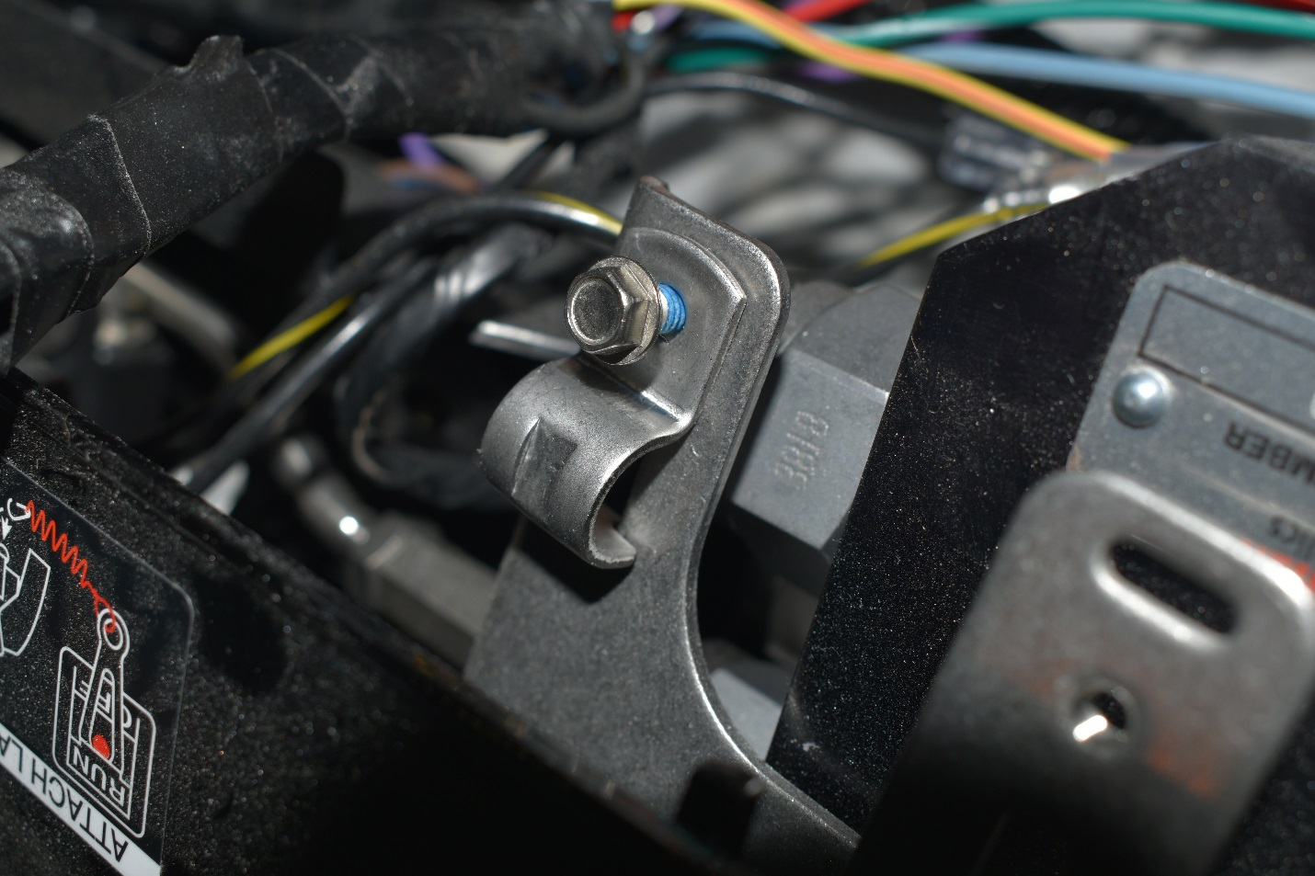
Attach the cable end to the shift/throttle levers.
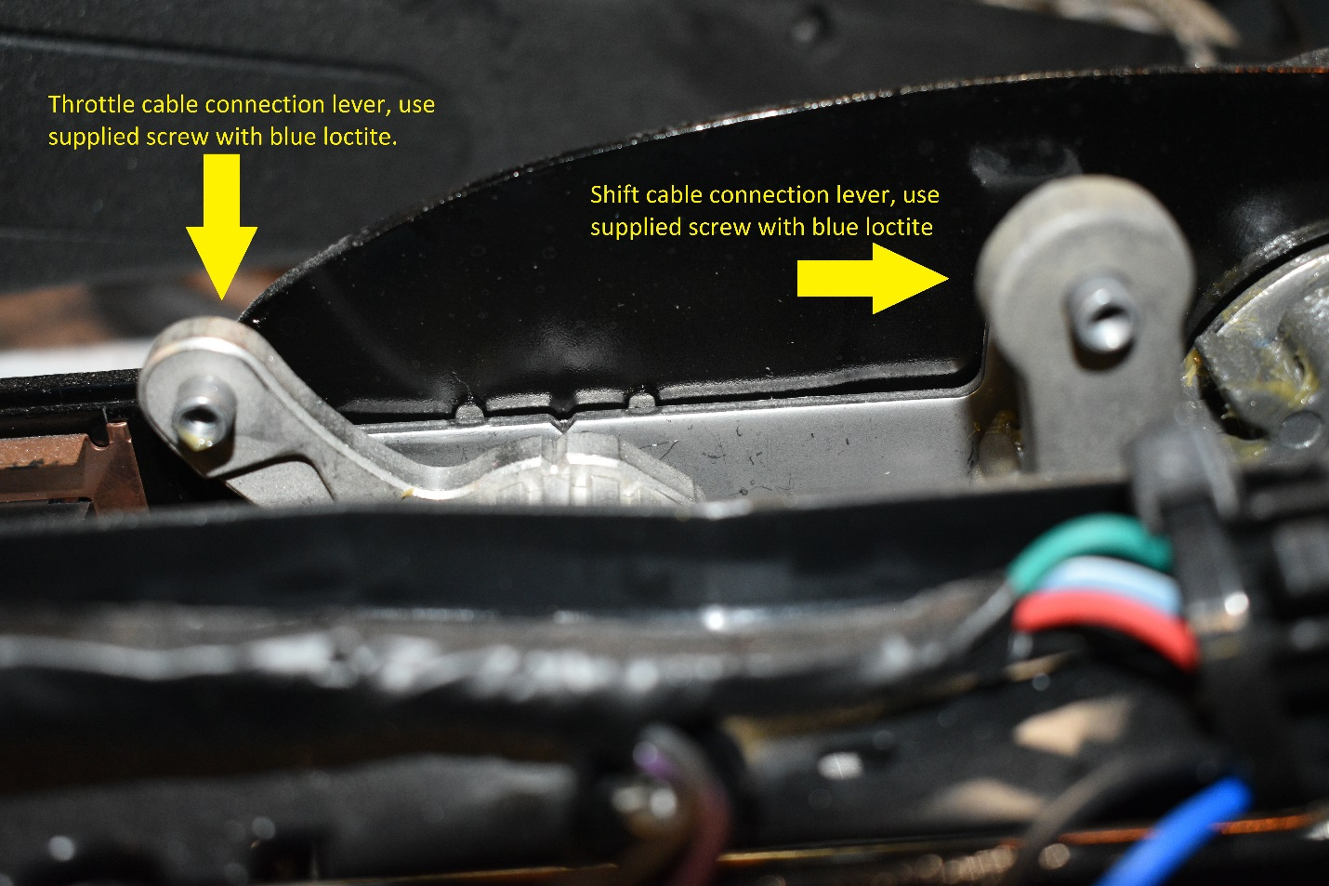
Mount power steering pump in a suitable protected location at least 4 ft. from the cranking battery. Connect power steering pump to the battery with the leads attached.
Connect supplied damper hose to power steering pump.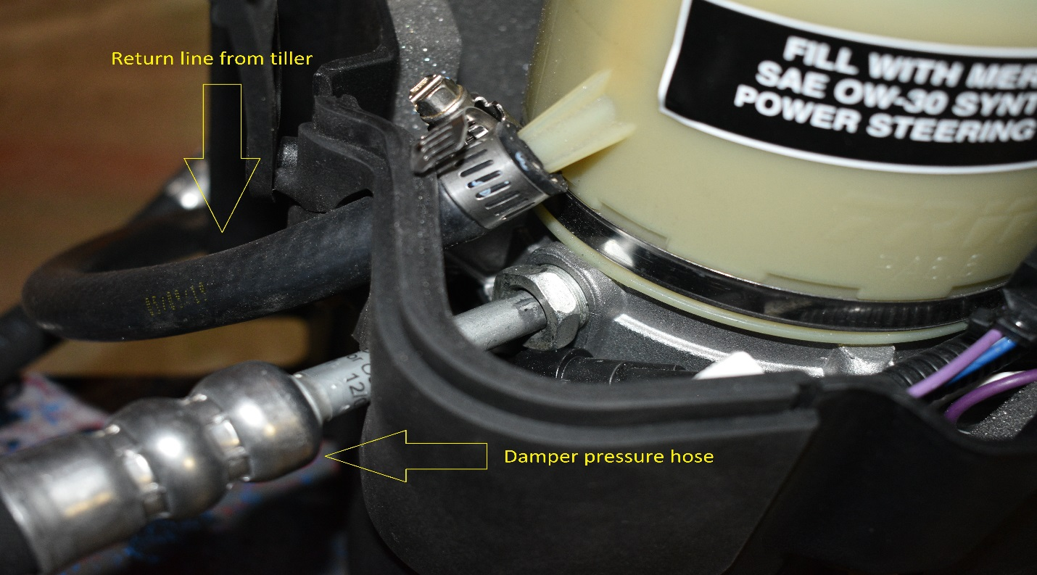
Connect the 10’ supply hose to the damper hose connection and connect to the pressure fitting on the tiller shown in the picture above.
Connect the return hose to the power steering pump utilizing the supplied hose clamp.

Attach the hoses to the tiller handle as shown below:
The supplied 3 Ft Hose will go on the PORT Steering cylinder connection (fitting to connect to the steering cylinder end cap will be on the hose)
The 4 Ft. Hose will go on the STARBOARD Steering cylinder connection (fitting to connect to the steering cylinder end cap will be on the hose)

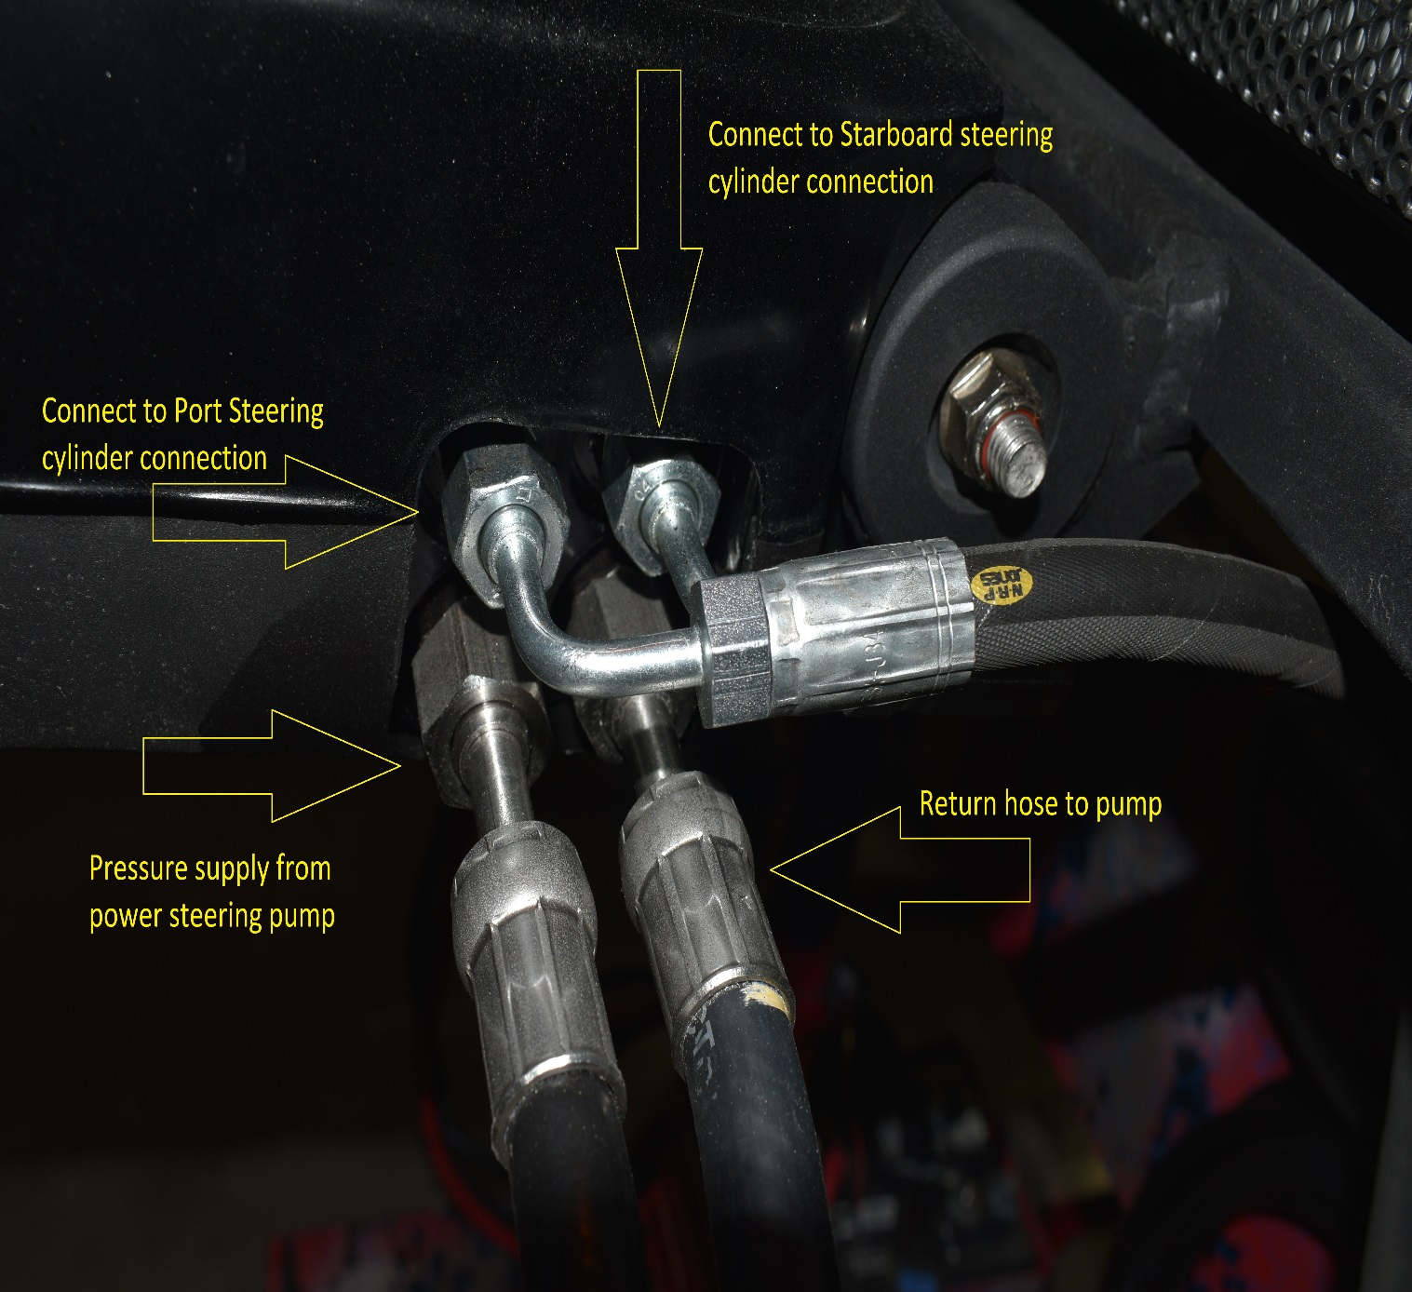

Attach the power steering extension harness to the harness on the power steering pump.
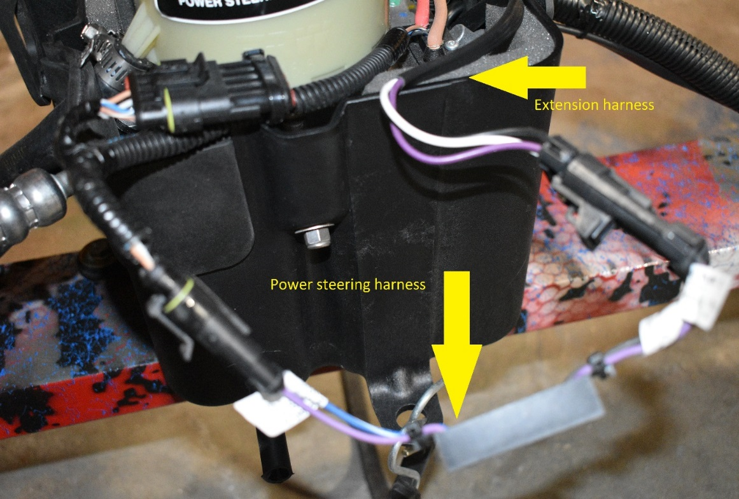
Route the extension harness and attach to the power supply harness.
Connect the the red wire to the positive battery connection, attach the black to the negative battery connection and attach the purple wire to the purple wire on the tiller harness connection.
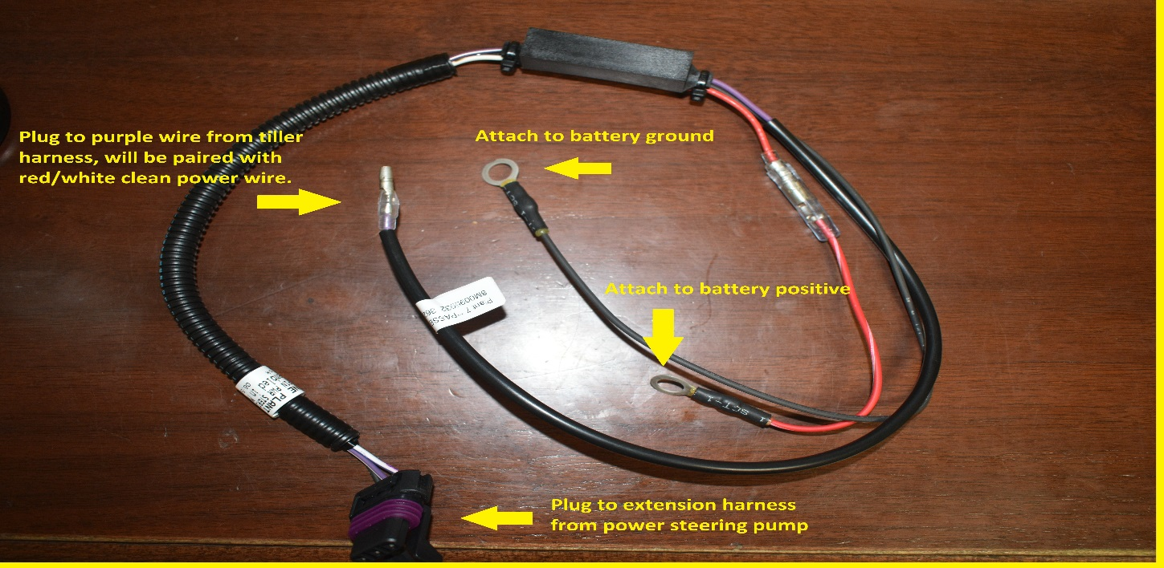

The red/white wire with the purple wire will connect to cranking battery positive post, this is 12V clean power to the ECM.
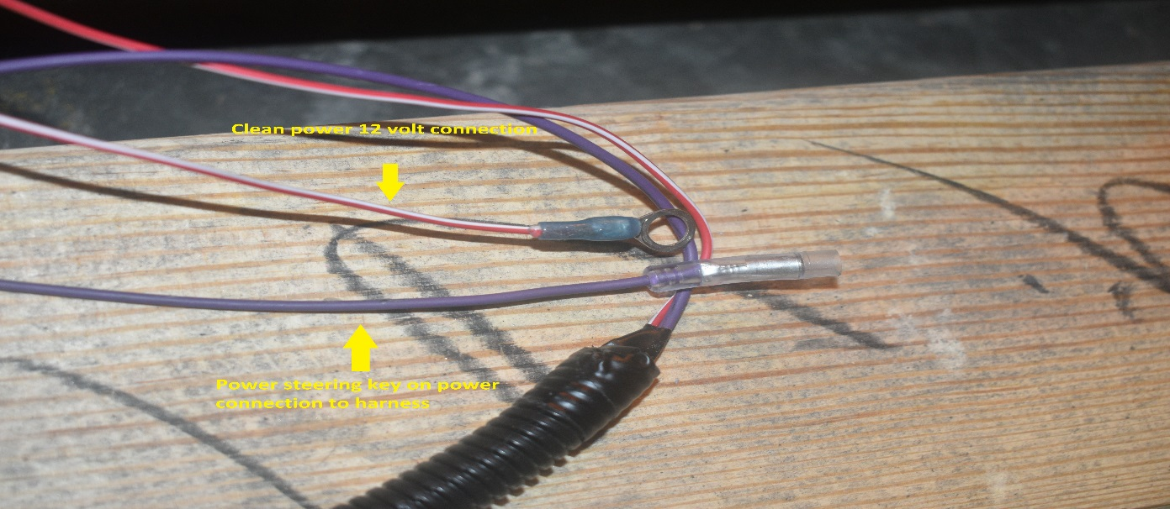

Install the potentiometer in a protected location (storage box, battery box, compartment) that will not have excessive vibration or open to the elements.

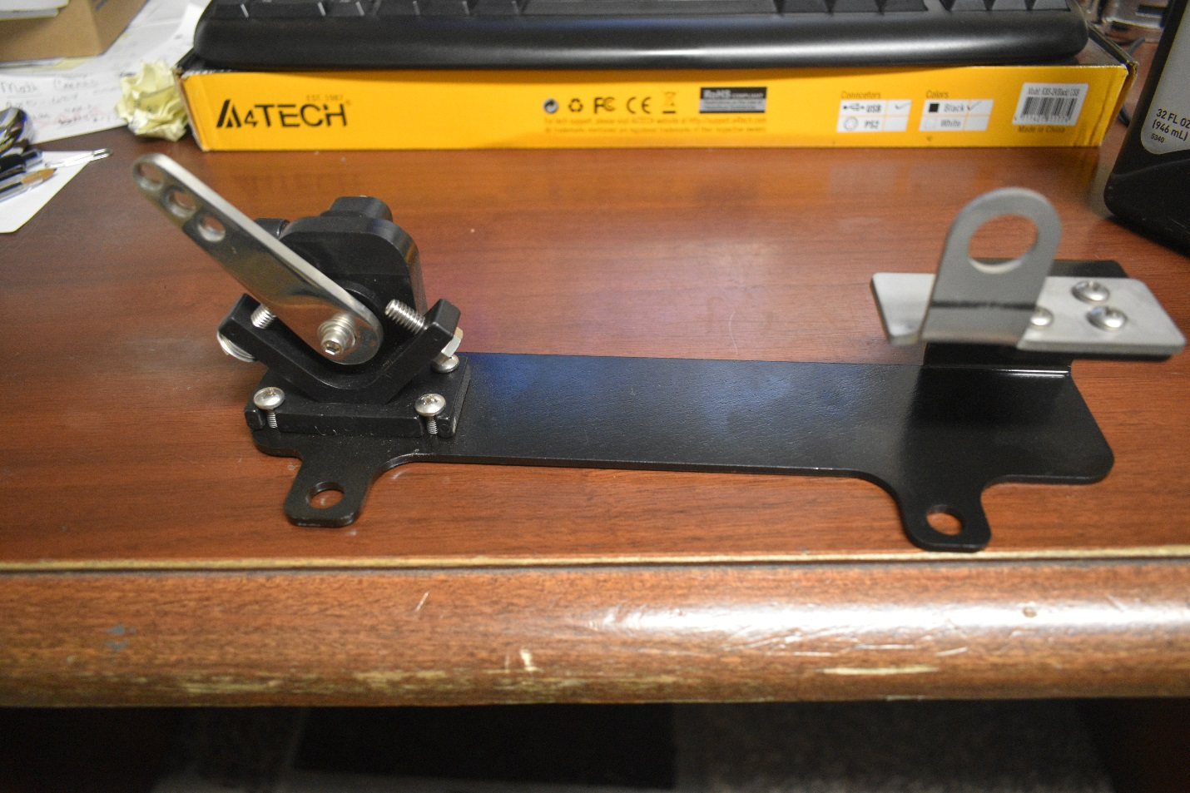

The wiring harness from the tiller will plug into the throttle rack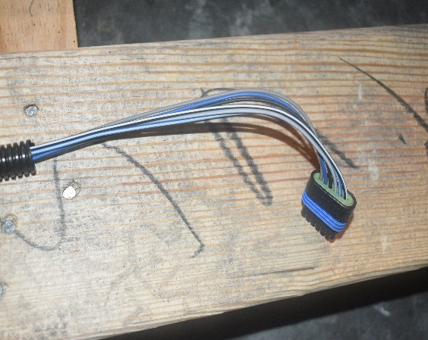

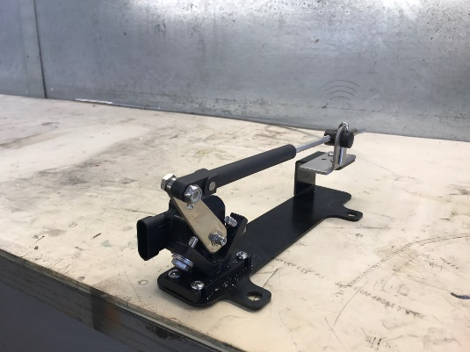

With the controller at idle, adjust the knob on the throttle rack end of the Gen II cable so the throttle rack is held just off the stop bolts in the idle position.

Before operating the power steering pump the reservoir must be filled with the Mercury Power Steering fluid
.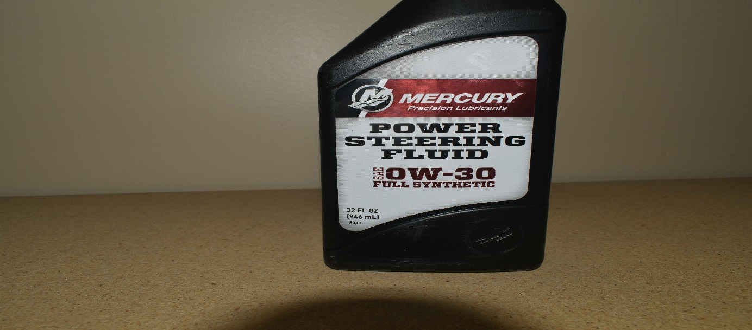
Turn key to the “ON” position, monitor reservoir and maintain fluid level. Exercise steering full range and verify operation and purge any air. The pump should purge all the air out. If you should have to manual bleed the system, install orbital fitting in the steering end glands and bleed per Mercury manual instructions.

Any questions on installation procedures please contact BOSS Technical Service or reference supplied installation manual provided with the kit from Mercury.

