Reverse Lock Cable Installation Instructions

Step 1: Insert cable through reverse lock box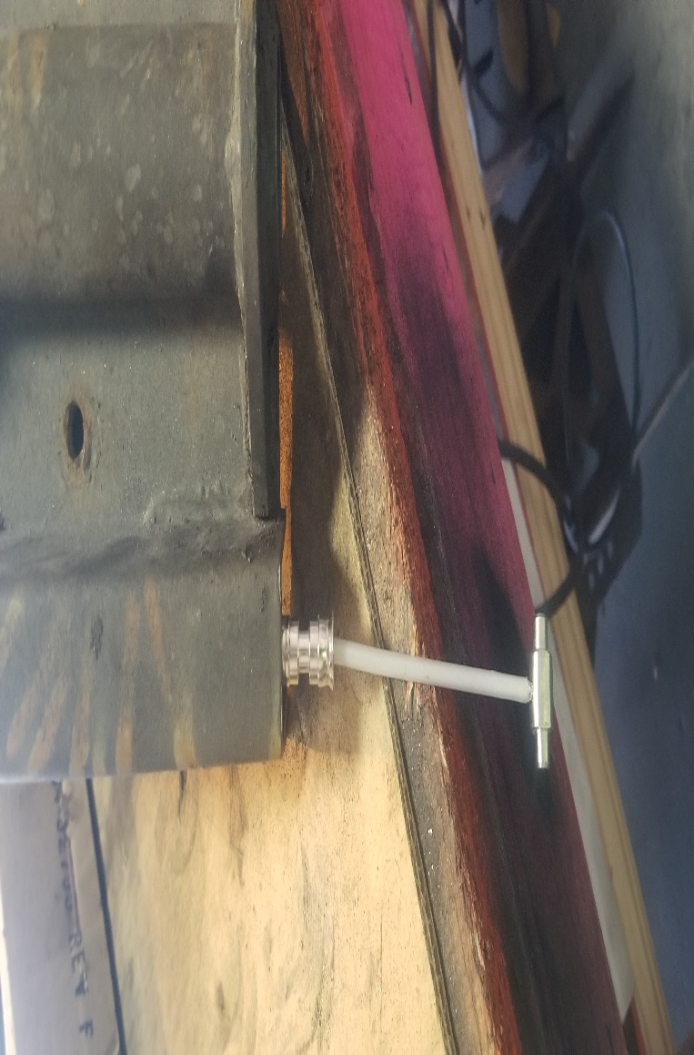
Step 2: Attach spring to reverse lock bracket
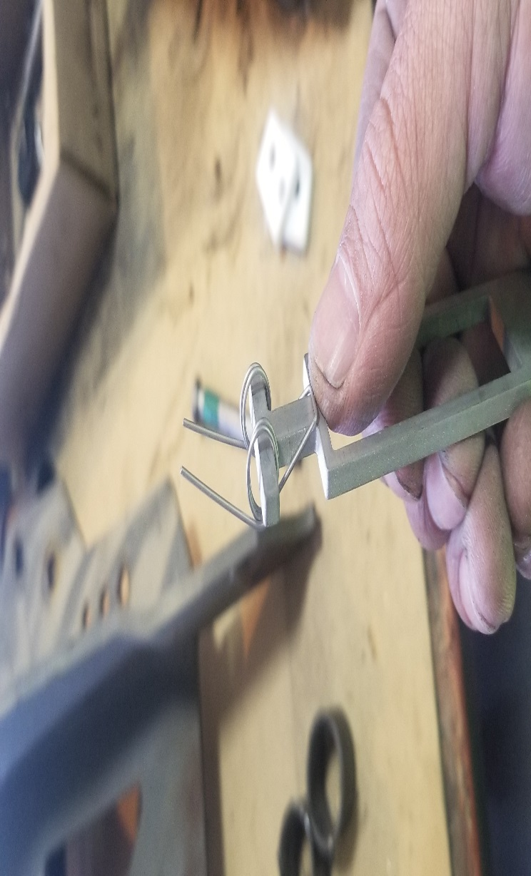

Step 3: Attach poly slides as shown and then rotate slides
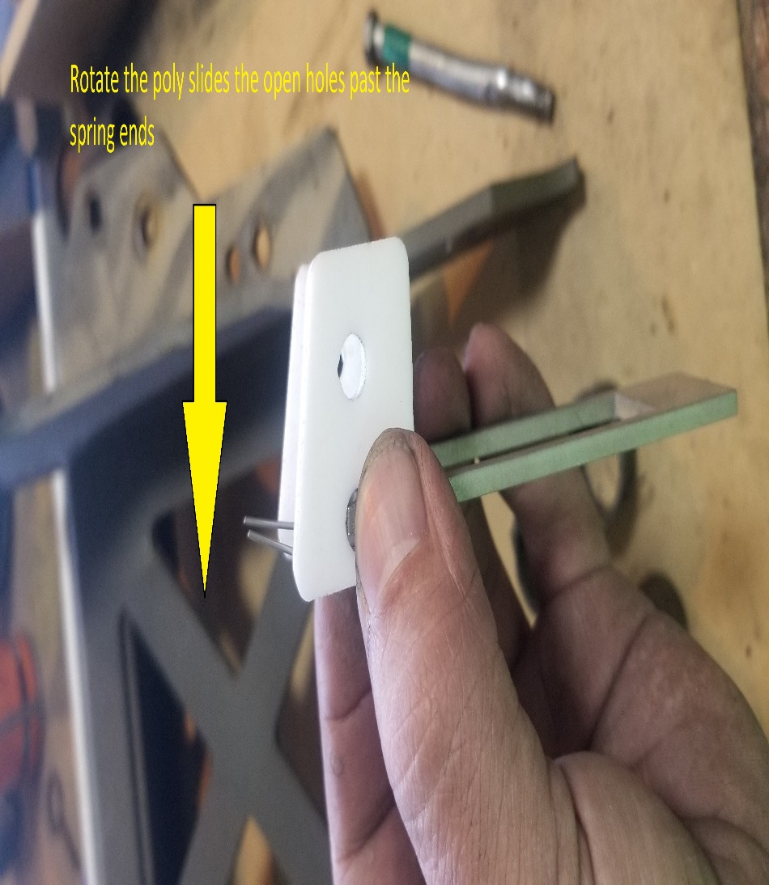
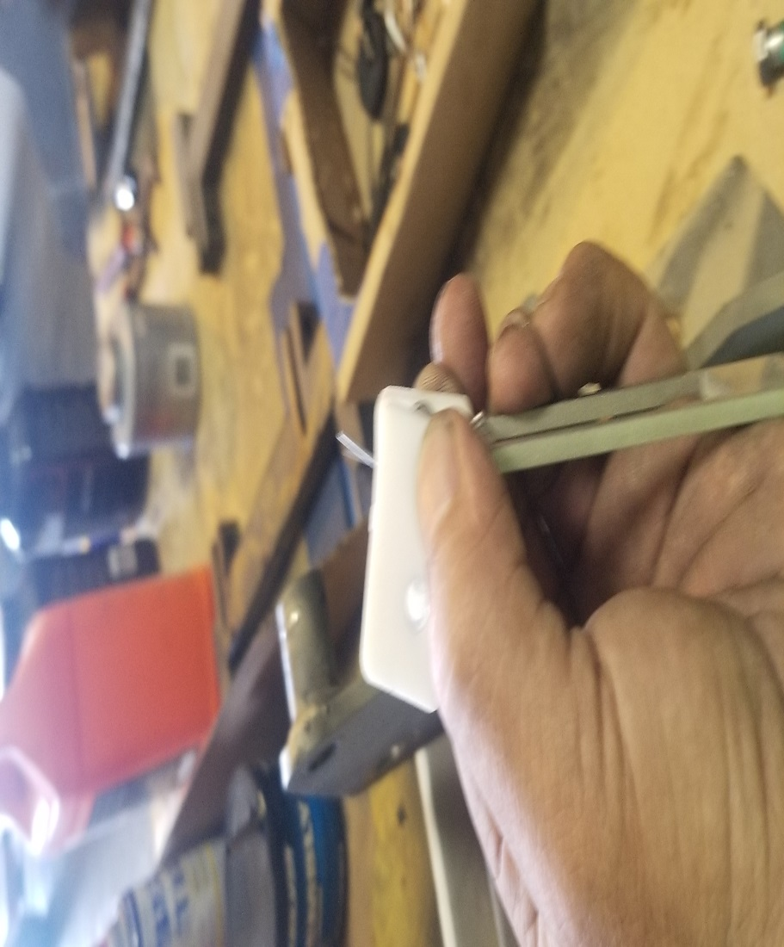
Step 4: Insert cable in the open poly holes
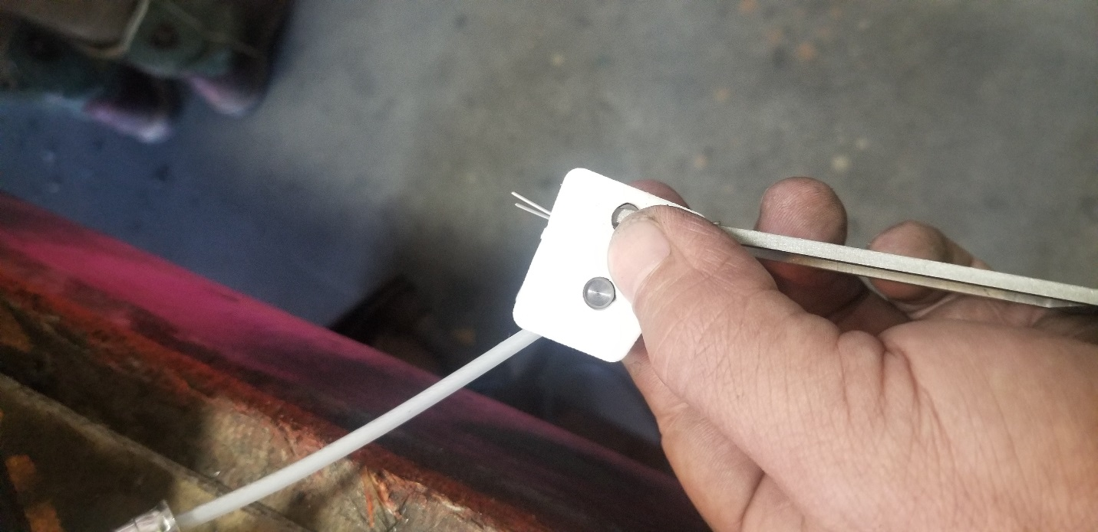

Step 5: Rotate cable and poly back to original location and should have spring tension on the bracket.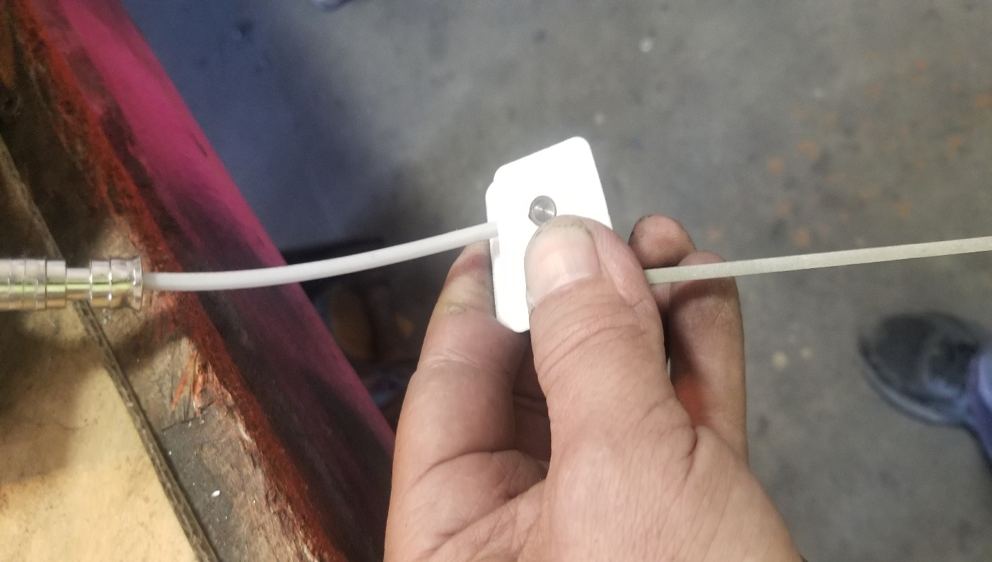

Step 6: Insert assembly into the reverse lock box and slide up (may have to tap up with a rubber hammer. Make sure inner and outer clapper are separated. When separated the reverse lock hook will not be in the reverse lock box.)
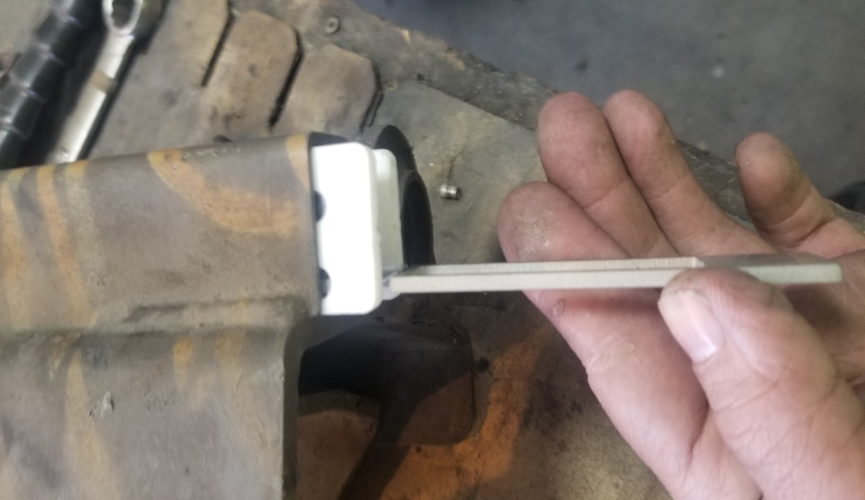

Install retaining bracket on the shift cable and install rivets to hold secure.

