Oil Canister Installation

Step 1:
Remove air filter cover and air filter. Unbolt (4) 8mm bolts securing the air filter plate to the throttle body, unbolt the (4) 12mm bolts securing the air filter plate to the engine brackets and remove air filter plate. (Note: the gasket may or may not stay attached to throttle body, it is recommended to remove and place with air filter plate.)
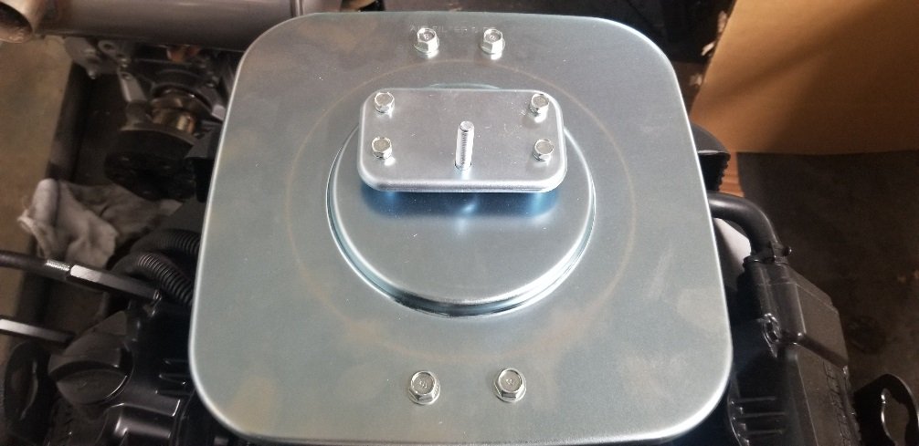

Step 2:
Route the short canister hose alongside the engine bracket and cradle the canister between the engine brackets and valve cover as shown below.
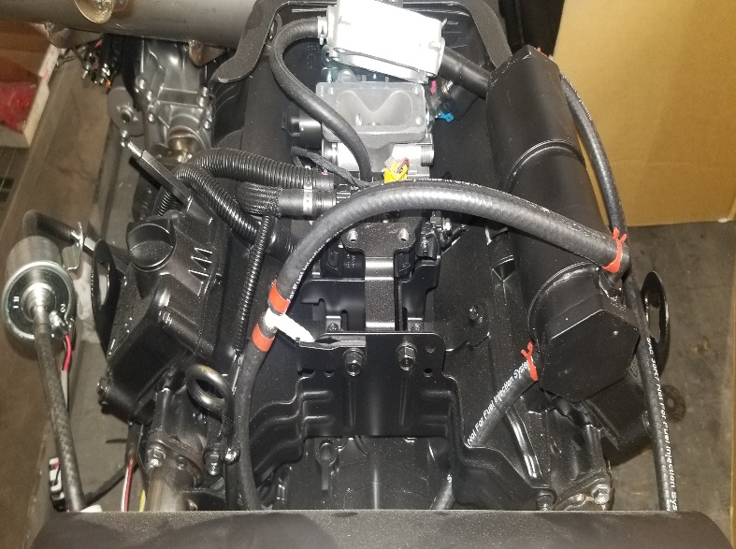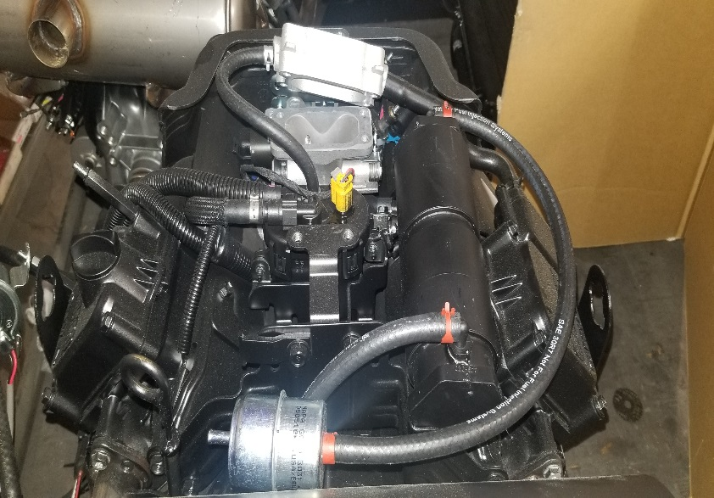

Step 3:
Secure the vent line hose to the (2) 10mm valve cover bolts utilizing the supplied (2) clamps, then secure the vent filter to the vent filter bracket with a supplied wire tie. (Note: the hose routing.)
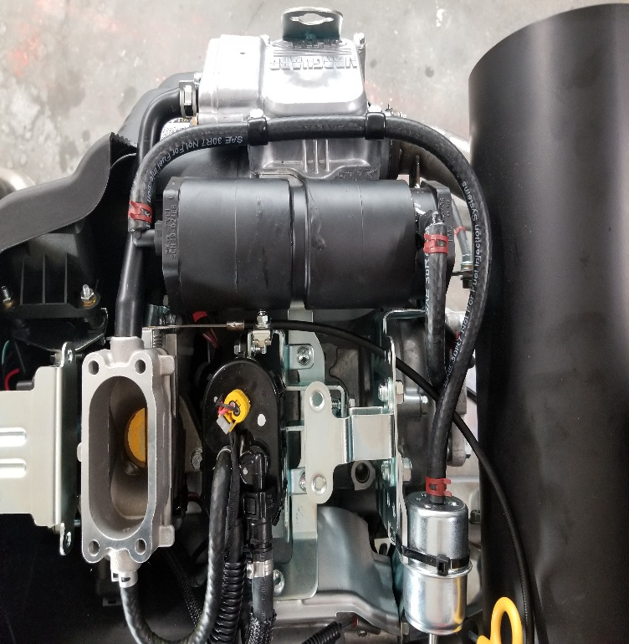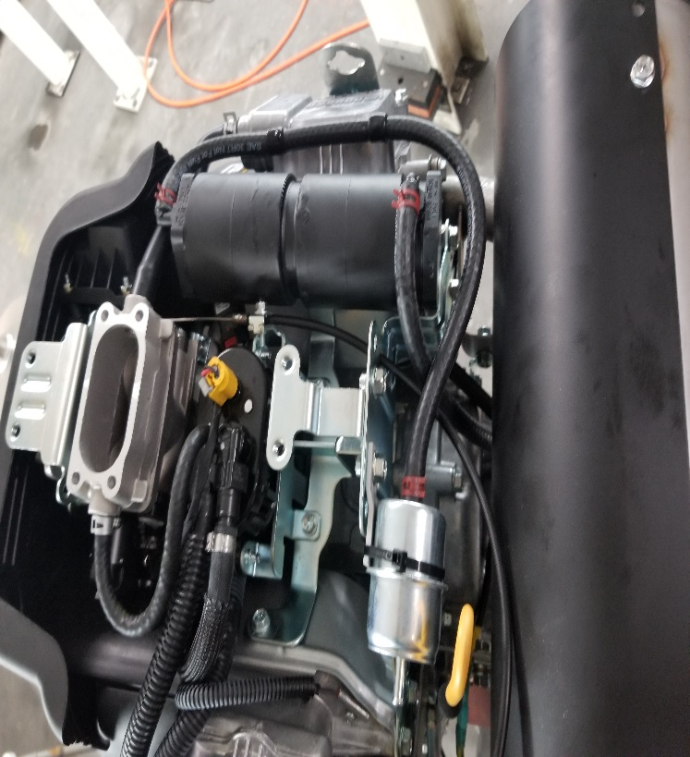
Step 4:
Attach the short hose to the “T” fitting as shown below. Then connect the bottom hose of the “T” fitting to the existing brass fitting under the transmission cover. To remove the transmission cover remove the (3) 1/4 Allen head socket bolts and remove the cover to access transmission vent line.
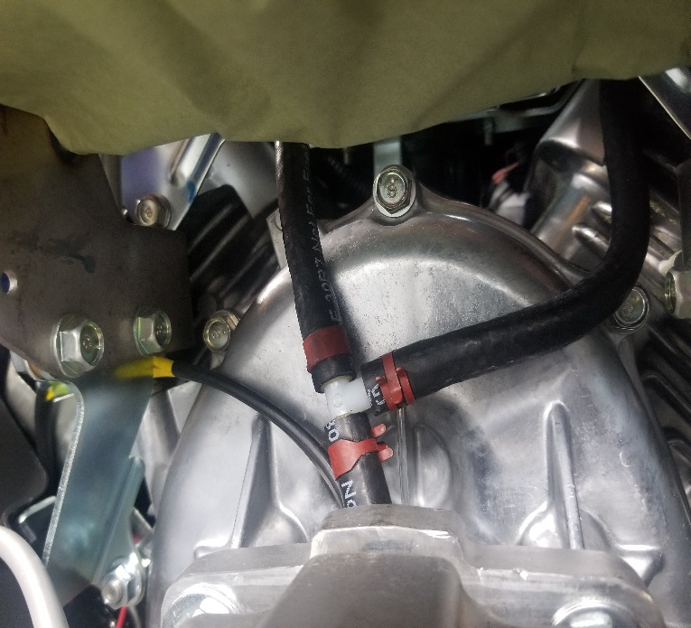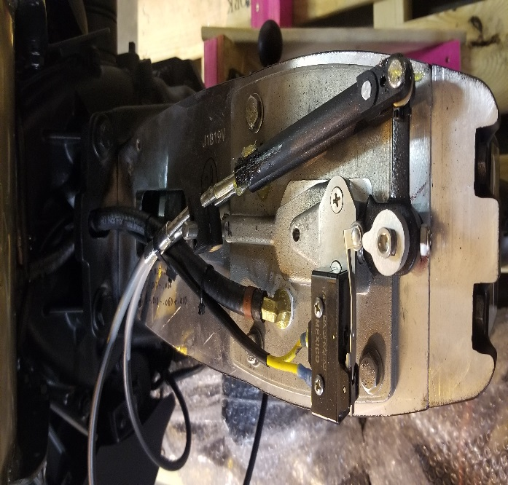

Step 5:
Reinstall transmission top cover with the (3) 1/4 Allen head socket bolts. Reinstall air filter plate with the (4) 8mm and (4) 12mm bolts removed in Step 1 (Note: make sure gasket is reinstalled at this time if it was removed). Install air filter and air filter cover.

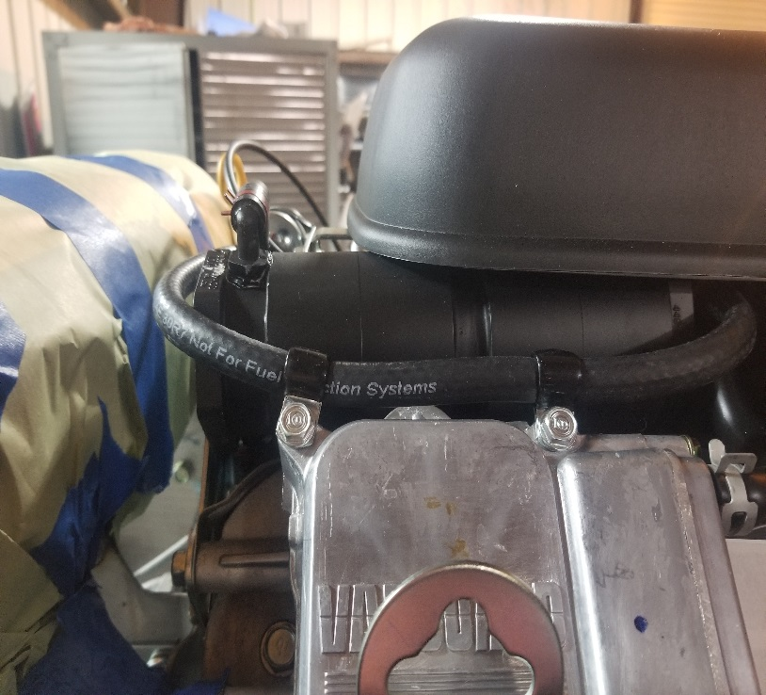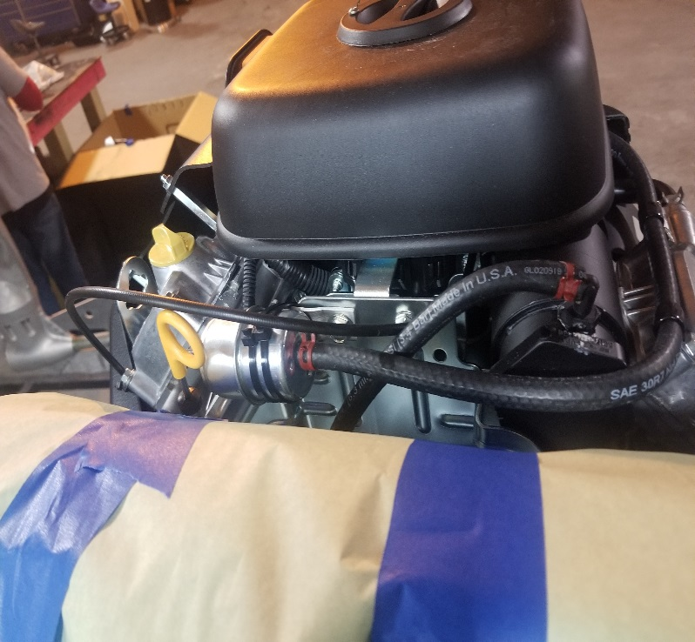

Torque Specs.
8mm air filter plate bolt – 78-96 in. lbs. (9-11 Nm)
12mm air filter plate bolt – 174-217 in. lbs (20-25 Nm)
10mm valve cover bolt – 70 in. lbs. (8 Nm)
¼ Allen head socket – 75 in. lbs.

