Service Bulletin

Bulletin # 2019-002

2019-002 Incorrect Installation of Transom Bolts Causing Premature Trim Failure.

Models Affected: All Models

Situation:
We have found that during an assembly run bolts were installed incorrectly causing damage to the trim pump manifold. This damage will cause the trim to fail. All dealers are asked to inspect current inventory and any units that come through service to address this issue before damage occurs. Below are pictures showing the correct and incorrect orientation of the bolts.
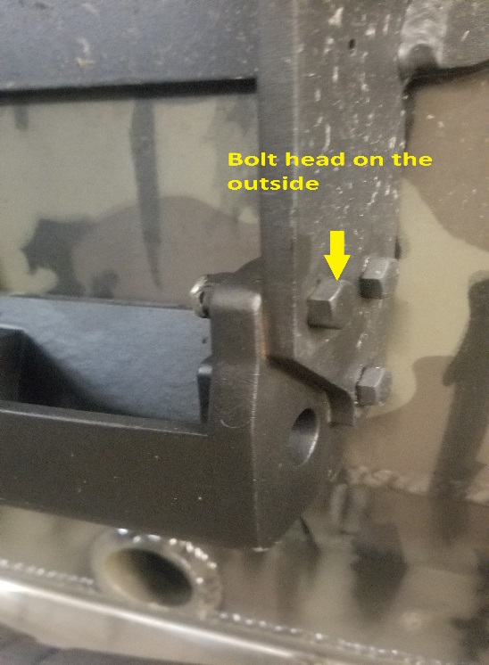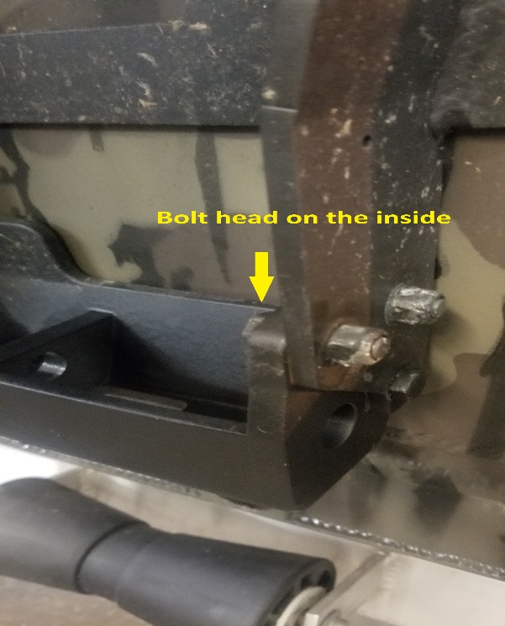
Incorrect Installation Correct Installation

This photo will show the damage incurred due to incorrect installation.
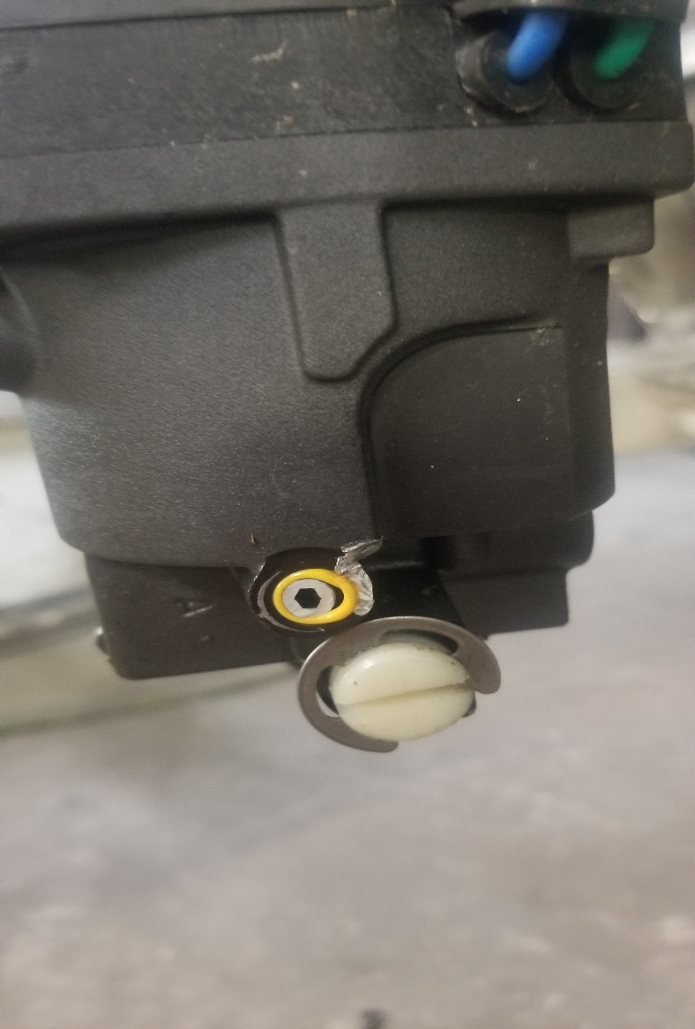

If dealers find a unit that have the bolt installed incorrectly and the trim has failed contact BOSS Technical Support before proceeding to the repair.
Correction
Follow the following procedures if there is no damage to the trim manifold:

- Set the drive on the travel pins and install keeper pin.
- Remove the bottom anode using a 10 mm socket. 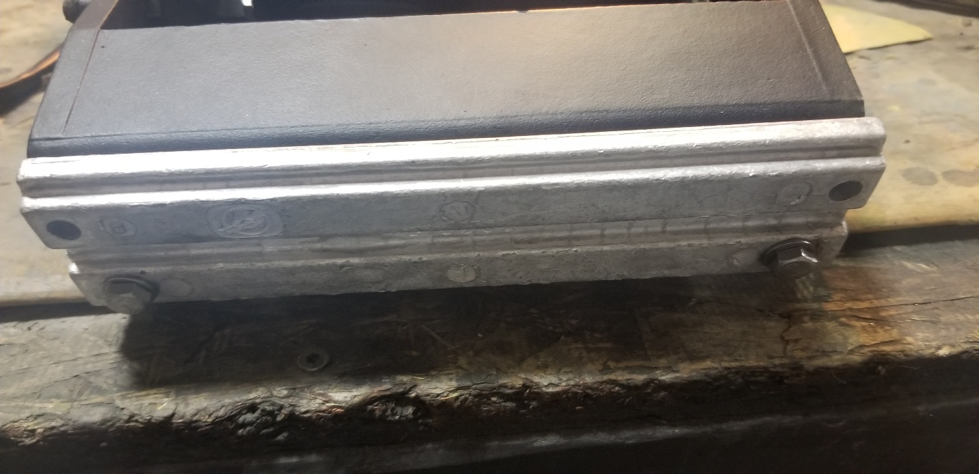
- Remove the bottom bolt of the trim, using a 3/4 wrench and a 5/16 Allen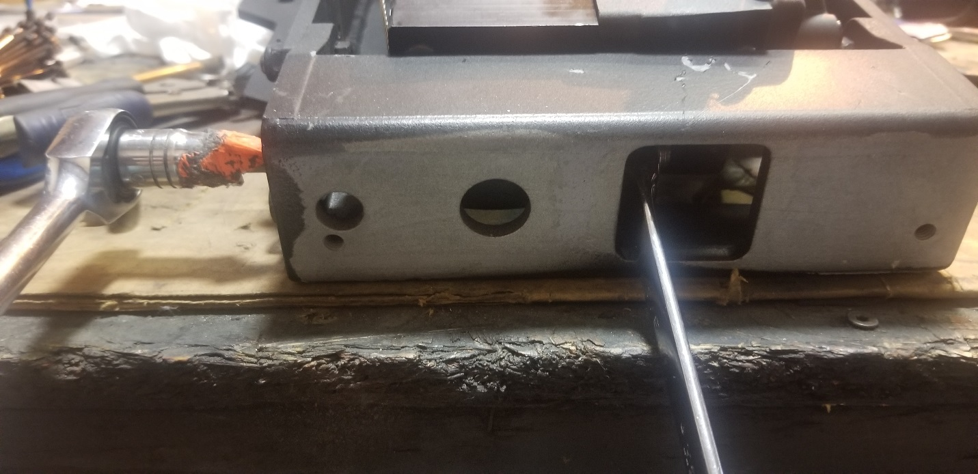
- Lift the power trim out of the cradle to access the bolt. 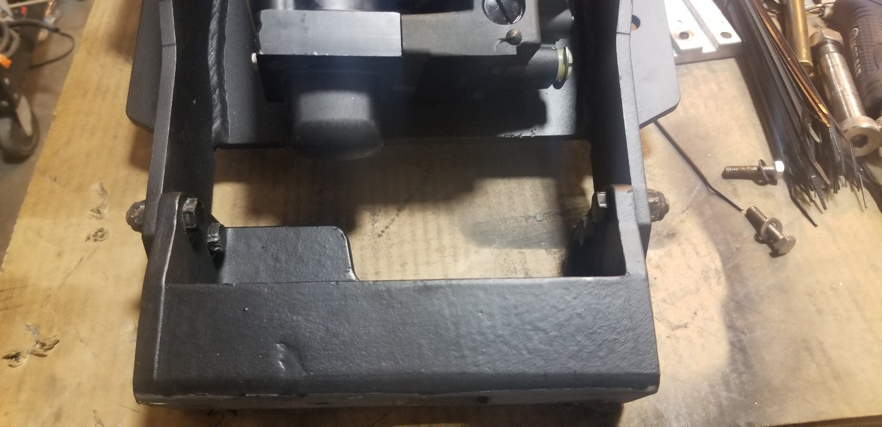
- Remove the bolt with ½ wrench and socket. Reinstall bolt from the inside putting the nut on the outside.
- Reinstall the trim in the cradle
- Apply anti-seize to the allen bolt for the trim. Install the bolt securing the trim in the cradle. Install lock nut and tighten. 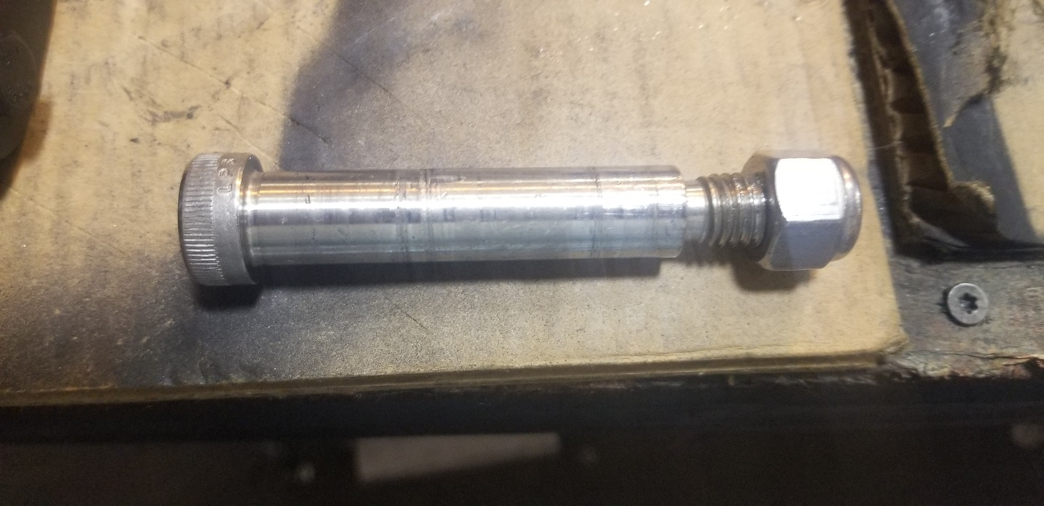
- Install the anode.
- Take the drive off of the travel pins and exercise the trim and verify no contact between the bolts and trim assembly.
If you are needing to replace the trim at Step 4, you will remove the upper trim pin. Then unwire the trim and remove and replace.

